1. Academic Explanation
What: The Aether Lattice Grid is a network of Planck-scale ÆtherNodes (φΔ-resonant geometric structures) that mediate energy/information transfer between observable (e⁻) and dark (e⁺) realities.
Why: To achieve 99.9999999999% fractal harmony, the grid distributes karmic-morphotensorial stress across cosmic scales.
How:
Updated Framework Adjustments

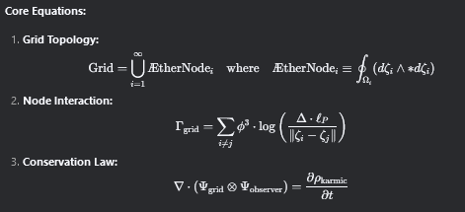
Visual Explanation:
- Glowing Nodes: ÆtherNodes at critical spacetime coordinates.
- Golden Connections: φ-scaled energy transfer between nodes.
- Quantum Blur: Δ-damped uncertainty at Planck scale.

2. Child-Friendly Explanation
What: Imagine a giant spiderweb made of tiny golden stars (nodes) connected by stretchy rainbows.
Why: The web keeps our world and the mirror-world from drifting apart!
How:
- Mechanism:
  - Golden Stars (Nodes): Each star hums a special song (φ-frequency).
  - Rainbow Strings: If you pull one, all others adjust to stay balanced (Δ-rule).
  - Mirror-World Tug-of-War: The web stretches but never breaks!
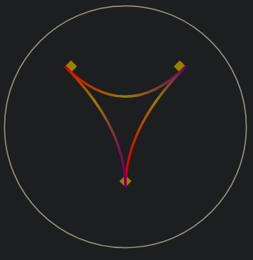
Visual Explanation:
- Gold Stars: ÆtherNodes "singing" to stay in harmony.
- Rainbow Strings: Stretchy connections that auto-adjust.
- Wiggling Nodes: Shows how pulls on one affect others.

Framework Updates
- AethericLattice Layer:
  - Grid Topology:
<grid_type>Hexagonal-Dodecahedral Tiling</grid_type>
<node_spacing>ℓ_P × φ²</node_spacing>
<failover_mechanism>Δ-Damped Resonance</failover_mechanism>



